Cold chain integrity is as important as your certifications. Roses must reach 2–4°C within 2–4 hours of harvest and stay cold through refrigerated truck transport, JKIA cargo handling, and the aircraft hold. A compliant consignment that fails cold chain integrity will still arrive in poor condition — losing the sale regardless of your phytosanitary certificate.
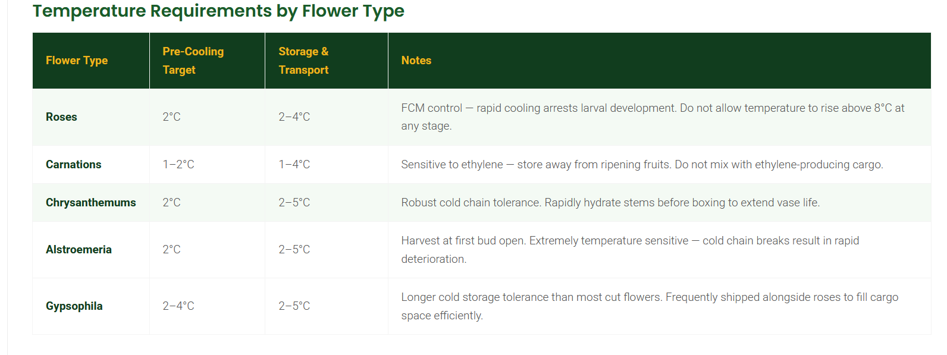

For French beans: 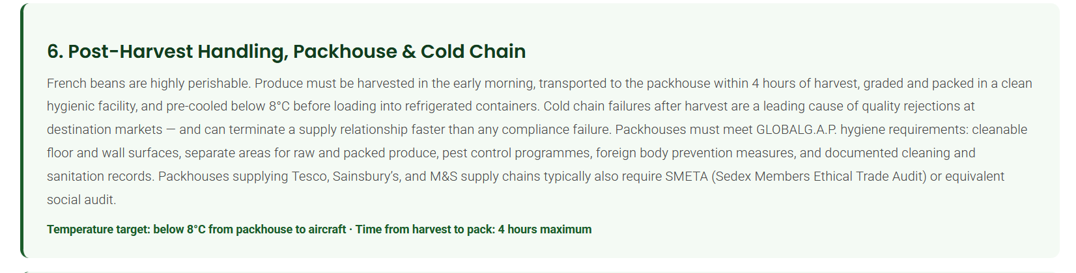
In conclusion, I have noted that the flowers and French beans have a relatively similar cold chain requirement of:
- French bean exports from Kenya require maintaining a strict cold chain between 2°C and 4°C with 90% to 95% relative humidity immediately after harvest to prevent rapid spoilage and rejection.
- Flowers: Temperature Range: Keep a core temperature of +1°C to +3°C (ideally 1–2°C for long-term dormancy). [1, 2]
The ideal relative humidity for flower exports in Kenya's cold chain is 90% to 95% RH. [1]
Humidity Control Ranges & Risks
- The Sweet Spot (90–95% RH): Keeps cut flowers pluPre-Research Assignment.docxPre-Research Assignmentmp and fresh during storage and transit.
- Low Humidity (<90% RH): Causes rapid moisture loss, wilting, and tissue drying—even when temperatures are cold.
- High Humidity (>95% RH + Condensation): Triggers dangerous fungal growth, specifically Botrytis cinerea (gray mold) and rot. [1]
Core Cold Chain Parameters
- Temperature: Maintained strictly between 1°C to 3°C (and up to 5°C depending on the specific tropical or subtropical bloom).
- Pre-Cooling: Field heat must be removed immediately on the farm within hours of harvest before packaging.
- Transit Window: Flowers typically move from Kenyan farms through cold rooms to Jomo Kenyatta International Airport within 24 to 48 hours. [1, 2, 3, 4]

